Term 2, December 2021  Registration forms  Please ensure we have an up-to-date registration form for your child/ren (filled out at any point throughout 2021). New registration forms are available from our website, or ask when you are at club for a paper copy. If any personal information changes please do remember to let us know and we can update the paperwork. Please also ensure we are aware of any allergies/asthma as we do not share medication or medical records with schools.  CCI open evening  We recently had a drop in session at Christchurch Infants for parents to come in and have a look around and see what their children had been up to. It was a lovely evening and we are hoping to hold more of them across the different sites through next year.  Clothing  We are still encouraging the children to play outside as much as possible to minimise the transmission of COVID. Please ensure your child goes to school with suitable clothing for after school club as it is getting colder on an evening now. |  | 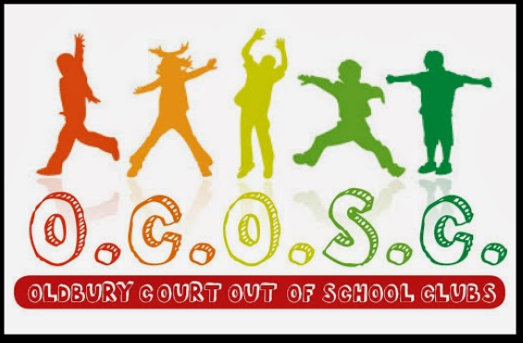  Upcoming Events  Gingerbread house workshop  We are holding a gingerbread house making workshop Saturday 18th December at 9.30am – approx. 11am. Each house is £12.50 and spaces are limited so please book in ASAP to ensure you get a place!  Please keep your eyes peeled for flyers and sponsor forms for our up-coming events
  Oldbury Court Out of School Clubs
  Contact us: 07747650611
  enquiries@oldburycourtclubs.org.uk
  Find and follow us on Facebook
  Fundraising
  Through the month of December we are continuing our efforts to have ongoing fundraising activities happening at all of our sites. This has involved the children planning and organising a mixture of events from sponsored challenges to setting up cake sales. Please support the children’s efforts when they come home with their sponsor forms or flyers – they have all put lots of thought into how they would like to raise money for their clubs.
  Important Announcement
  From the start of the New Year we will be re-instating our lost deposit policy. We waived the policy through the pandemic as we appreciated that the situation was constantly changing and it was frequently difficult to let us know in advance what your childcare would need to be. Now we have a busier club it is important that we know in advance if your child does not need to be collected for ASC as looking for children results in collections to other schools being late. Please see your contract for the charges that will be implemented.
  50/50 Congratulations to B.GLEESON for winning Decembers 50/50 draw.

