Term 3, January 2022  AGM  We will be holding our AGM in July this year. Our registration period now runs with the school year (rather than the calendar year) so please ensure you attend the AGM to book in for the start of the school year. We will send out the date nearer the time.  Late payments  Throughout the pandemic we appreciated that many families had difficulties with payments so late fees had been waived until now. Please ensure you are up to date with payments as from February 2nd the late fee will be reinstated as per your contracts. If you pay using childcare vouchers please remember these take a few days to enter our bank account so will need to be paid in advance to ensure we receive the funds by the first of the month.  Each monthly payment is clearly outlined on your invoice – if you would like to have a copy of your invoice emailed to you please email us at enquiries@oldburycourtclubs.org.uk.  Staff update  This year we have said goodbye to 2 of our lovely staff team. Katrina Curtis has worked at OCOSC since 1994, becoming a level 3 playworker and deputy manager over the years. Jessica Lockier has worked for us as a playworker since 2019. We wish them both luck in their future careers and both staff will be missed by children and colleagues alike. |  | 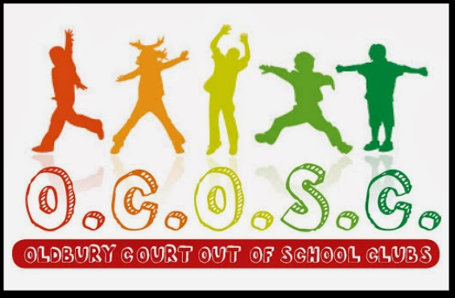  Upcoming Events  Gingerbread house workshop  We are holding a gingerbread house making workshop Saturday 18th December at 9.30am – approx. 11am. Each house is £12.50 and spaces are limited so please book in ASAP to ensure you get a place!  Please keep your eyes peeled for flyers and sponsor forms for our up-coming events
  Oldbury Court Out of School Clubs
  Contact us: 07747650611
  enquiries@oldburycourtclubs.org.uk
  Find and follow us on Facebook
  Welcome back!
  We hope you all had a lovely break over Christmas and New Year. Holiday club was filled with lots of fun activities – hundreds of arts and crafts went home for decorating trees, mince pies and pizzas were made along with woodwork, dancing and football workshops.
  If you would like to book in for our February half term please return a booking in form (from our website) by February 4th.
  Important Announcement
  50/50 Congratulations to B.GLEESON for winning Decembers 50/50 draw.

